**The President and Fellows of Harvard College Harvard Art Museum**

A Chinese Bronze Mirror

Author(s): Sheila Rubin

Reviewed work(s):

Source: *Annual Report (Fogg Art Museum),* No. 1955/1956 (1955 - 1956), pp. 58-59+64 Published by: The President and Fellows of Harvard College on behalf of the Harvard Art Museum Stable URL: <http://www.jstor.org/stable/4301286>

Accessed: 11/05/2012 08:00

Your use of the JSTOR archive indicates your acceptance of the Terms & Conditions of Use, available at <http://www.jstor.org/page/info/about/policies/terms.jsp>

JSTOR is a not-for-profit service that helps scholars, researchers, and students discover, use, and build upon a wide range of content in a trusted digital archive. We use information technology and tools to increase productivity and facilitate new forms of scholarship. For more information about JSTOR, please contact [support@jstor.org](mailto:support@jstor.org).

|  |  |
| --- | --- |
|  | *The President and Fellows of Harvard College* and *Harvard Art Museum* are collaborating with JSTOR to digitize, preserve and extend access to *Annual Report (Fogg Art Museum).* |

A CHINESE BRONZE MIRROR

This round mirror 1 has a nearly flat face but is decorated on the reverse by designs in relief. The central knob is a lion whose arched body forms the loop for the cord handle. About him are four beasts reclining on a ground of tendrils and butterflies enclosed by a raised "vine" rim with twelve clusters of grapes on its inner side. In an outer zone are insects and butterflies alternating with two pair of flying geese and two pair of birds perched among hanging clusters of grapes. The border is a thin rim with an inner band of a convention­alized pattern.

This mirror is a fine example of the "sea horse and grape type." Twenty seven of these were recorded in the *Ming Shou Chien Ku,* a description of the bronzes in the Imperial Collection commissioned by the Emperor Ch'ien Lung.2 The vine and grape motif first appears in Sassanian art and its use here demonstrates Persian influence.3 In the early twelfth century, Sung antiquarians dated these mirrors in the Han period (2o2 B.C. — A.D. 220), associating them with the famous traveller, Chang Chien. According to tradition, he had in­troduced grapes into China when he returned from his trip to Bactria in 126 B.C. Now most scholars believe that the sea horse and grape mirrors date from the T'ang Dynasty (A.D. 638-906) but made their first appearance late in the preceding Six Dynasties period. The Persian influence found here, as well as the naturalistic forms skillfully represented in high relief, are characteristic of the art of the T'ang Dynasty. The graceful geese and the beautifully rendered grapes are quite different from the stylized designs of the Han period. The exu­berance of the over-all pattern suggests a date in the middle T'ang period, the 7th or 8th century.

Probably this object has deep symbolic meaning. The Chinese mirror served a twofold purpose: the functional reflecting face is complemented by a reverse with ornament suggesting the cosmos, designed to catch the divine light of heaven.4 The scheme consists of a point (the lion) circumscribed by two circles—the axis of the

*(continued on page 64)*

*1*Bronze, all-over greenish-black patina. 51/4" in diameter. Gift of Philip Hofer, in memory of Langdon Warner.

'R. W. Swallow, *Ancient Bronze Chinese Mirrors,* Peiping, 1937, p. 52. 3 *W.* P. Yetts, *The Cull Chinese Bronzes,* London, 1939, p. 161.

J. M. Plumer, *Design and Technique in Ancient Chinese Bronze Mirrors,*

Ann Arbor, 1941.

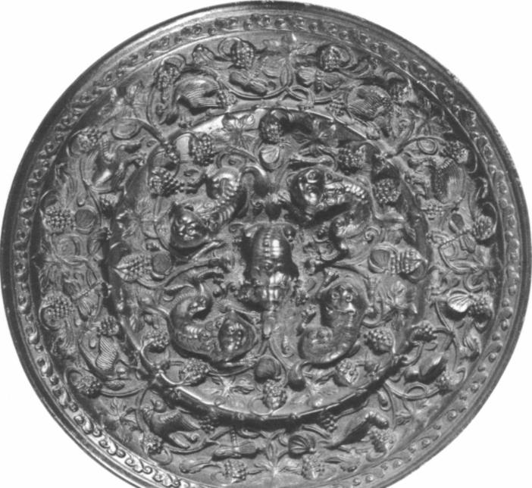

HARVARD UNIVERSITY

fails to solace the painted woman. Beckmann believed that to grasp the intangibles, one must grasp reality with the greatest force.9 In *The Actors* he implemented his axiom by expressing, in his choice of the grand and the sordid, an indulgent understanding of the eternal human drama.

**CHARLES CHETHAM**

The philosopher's bust recalls another phrase from Beckmann's On *My Painting, Op. Cit.* "I thought of my grand old friend Henri Rousseau, that Homer in the porter's lodge whose pre-historic dreams have sometimes brought me near the gods," p. 13.

9 Max Beckmann, *Op. Cit.,* p. **4.**

A CHINESE BRONZE MIRROR *(continued)*

universe surrounded by the bands of heaven. The outer band, indi­cating the rim of the encompassing dome of the sky, completes the cosmic symbolism.

Cammann has suggested that this type of ornament may also have a hedonistic significance in keeping with the materialistic outlook of the T'ang court.5 The lion patterns originated in early T'ang times and may represent the same idea in sculpture as the "Dance of the Lions of the Five Directions." This, accompanied by the music of "Universal Peace," was a popular musical performance at the Chinese court during the Sui and T'ang Dynasties. The profusion of grapes, symbolic of luxurious eating and drinking, and the birds, symbols of music and joy, accord with a concept of the world at peace, a concept highly agreeable to the Chinese who had finally emerged from four centuries of general chaos.

In T'ang art, representations of birds are also symbolic of happy marriage. Birds and flying geese depicted in pairs facing one another, though common in other mirrors of the period, are rather unusual in the elaborate sea horse and grape type. Perhaps this was a marriage mirror.

**SHEILA RUBIN**

S. Cammann, "The Lion and Grape Patterns of Chinese Bronze Mirrors," *Artibus Asiae,* XVI, 1953, pp. 272ff.